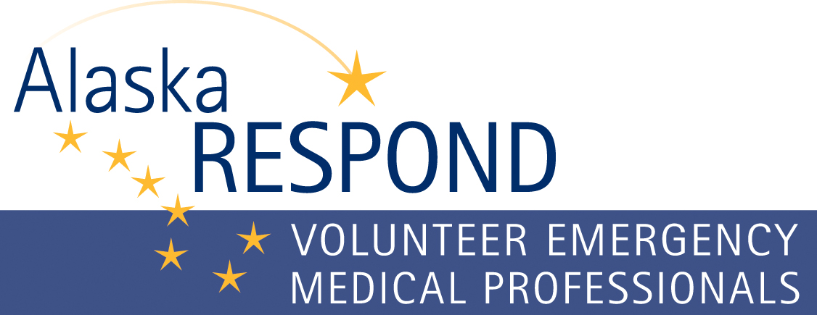
Alaska Respond volunteers may be requested to supplement healthcare personnel for a variety of disasters or public health emergencies. Listed below are considerations, and steps on how to submit the request form.

Considerations
- Before requesting AK Respond volunteers contact the DHSS Emergency Operations Center 24/7 Duty Officer at 907-903-3721 to discuss the situation the may require AK Respond volunteers.
- The DHSS Incident Commander in consultation with the AK Respond Coordinator must verify if the hospital has exhausted all local resources before activating AK Respond.
- Once DHSS Emergency Operations Center activates AK Respond and sends out the notification to volunteers, it can take up to 48 hours for deployment. The delay in time is dependent upon deployment location, volunteer status i.e. state emergency hire vs. hospital hire, travel method and availability of volunteers. The more specialized the type of provider the less likely we can meet your request. Consider AK Respond volunteers as generalists to back up your staff. (i.e. you may be able to shift your staff to the affected department and use AK Respond volunteers to staff a general unit.)
- AK Respond Coordinator will coordinate “Just in Time” training for volunteers, but recommends volunteers shadow facility staff to ensure they are following facility policies and procedures and have access to necessary pharmaceuticals, medical supplies and equipment.
- Send a map of the community and healthcare facility with the request to facilitate quicker deployment.

Steps to Request AK Respond Volunteers
Step 1: Complete the Healthcare Facility Checklist for Mobilization of Alaska Respond Volunteers Form. The form can be accessed from the AK Respond website www.akrespond.alaska.gov or request the form from dhsseoc@alaska.gov.
Step 2: Submit the completed form to dhsseoc@alaska.gov or fax to 907-269-0036.
Step 3: The AK Respond Coordinator or designee will initiate contact with the requesting entity to validate the information on the form and keep an open channel for communication on this request.

How to Complete the Healthcare Facility Checklist for Mobilization of Alaska Respond Volunteers Form
- Write legibly or complete the form in Microsoft Word. If completing the form by hand, use a dark ink.
- Complete the contact information at the top of the form.

Section 1: Circle yes or no, if your healthcare facility has exhausted all internal resources.
Section 2: Circle yes or no, if your healthcare facility has exhausted all community resources.
Section 3: Document the quantity of licensed healthcare professionals and specialty requested.
Section 4: Document the type of healthcare professional and check the box for the length of deployment the volunteers are needed at your facility. Add additional boxes if needed.
Section 5: Document the type of healthcare professional and check the box for which shift they will work. Add additional boxes if needed.
Section 6: Identify the desired employee status for each type of licensed healthcare volunteer.
- If the volunteer column is checked, an AK Respond volunteer may not deploy if they are not covered with liability or workman’s compensation.
- If your facility will hire the AK Respond volunteer, consider the paperwork needed to complete.
- If requesting state emergency hire, it may take additional time to deploy.
Section 7: Complete each question for where the volunteers will go once they arrive at your facility. Provide as much information as possible.
Section 8: Complete each question for the volunteer deployment logistics.
Section 9: Estimate when the volunteers need to report to your facility. Remember it can take up to 48 hours to deploy AK Respond volunteers, depending upon the situation and location.
Section 10: Open area to list questions or comments.

