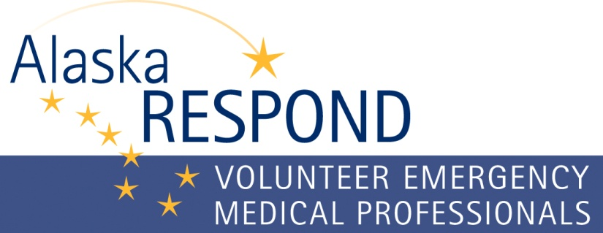
Alaska Respond volunteers may be requested to supplement healthcare personnel for a variety of disasters or public health emergencies. Listed below are considerations, and steps on how to submit the request form.

Considerations
- Before requesting AK Respond volunteers contact the DHSS Emergency Operations Center 24/7 Duty Officer at 907-903-3721 to discuss the situation that may require AK Respond volunteers.
- The DHSS Incident Commander, in consultation with the AK Respond program personnel, will verify if the community / hospital has exhausted all local resources before activation of AK Respond.
- Once DHSS Emergency Operations Center activates AK Respond and sends out the notification to volunteers, it can take up to 48 hours for deployment. The delay in time is dependent upon deployment location, volunteer status i.e. state emergency hire vs. hospital hire, travel method and availability of volunteers. The more specialized the type of provider, the less likely we can meet your request. Consider AK Respond volunteers as generalists to back up your staff. You may be able to shift your staff to the affected department and use AK Respond volunteers to assist in triage, staff a first aid or treatment center or a general hospital unit.
- AK Respond will coordinate and present “Just in Time” training for volunteers. It is recommended that volunteers shadow facility staff to ensure they are following facility policies, procedures and have access to necessary pharmaceuticals, medical supplies and equipment.
- Send a map of the community and healthcare facility with the request to facilitate quicker deployment.

Steps to Request AK Respond Volunteers
Step 1: Complete the “Checklist for Mobilization of Alaska Respond Volunteers Form”. The form can be accessed from the AK Respond website www.akrespond.alaska.gov or request the form from dhsseoc@alaska.gov.
Step 2: Submit the completed form to dhsseoc@alaska.gov or fax to 907-269-0036.
Step 3: The AK Respond program personnel will initiate contact with the requesting entity to validate the information on the form and keep an open channel for further communication on this request.

How to Complete the “Checklist for Mobilization of Alaska Respond Volunteers” Form
• Write legibly or complete the form in Microsoft Word. If completing the form by hand, use a dark ink.

Contact Info Complete the contact information at the top of the form.
Section 1: Circle yes/no if your healthcare facility has exhausted all internal resources.
Section 2: Circle yes/no if you have exhausted all community resources.
Section 3: Document the quantity of licensed healthcare professionals and specialty requested.
Section 4: Document the type of healthcare professional and check the box for the length of deployment the volunteers are needed at your facility. Add additional boxes if needed.
Section 5: Document the type of healthcare professional and check the box for which shift they will work. Add additional boxes if needed.
Section 6: Identify the desired employee status for each type of licensed healthcare volunteer.
- If the volunteer column is checked, an AK Respond volunteer may not deploy if they are not covered with liability or workman’s compensation.
- If your facility will hire the AK Respond volunteer, consider the paperwork that they will need to complete.
- If requesting state emergency hire, it may take additional time to deploy.
Section 7: Complete each question for where the volunteers will go once they arrive at your facility. Provide as much information as possible.
Section 8: Complete each question for the volunteer deployment logistics.
Section 9: Estimate when the volunteers need to report to your facility. Remember it can take up to 48 hours to deploy AK Respond volunteers, depending upon the situation and location.
Section 10: Open area to list questions or comments.

Revised 8/3/2016

